SCHOOL OF COMPUTER SCIENCE AND ARTIFICIAL INTELLIGENCE |  |  |  |  | DEPARTMENT OF COMPUTER SCIENCE ENGINEERING
ProgramName:M. Tech |  |  |  | AssignmentType: Lab |  |  | AcademicYear:2025-2026
CourseCoordinatorName |  |  |  | Venkataramana Veeramsetty
CourseCode |  |  |  | CourseTitle |  | AI Assisted Problem Solving Using Python
DateandDay  of Assignment |  |  | Week5 - Monday | Time(s)
AssignmentNumber:10.1(Presentassignmentnumber)/24(Totalnumberofassignments)
 | Q.No. | Question
 | Q1.  Q2.  Q3.  Q4.  Q5.  Q6. | Task Description #1 – Refactor Nested Conditionals  Task: Provide AI with the following nested conditional code and ask it to simplify and refactor for readability.  Python script.  def discount(price, category):  if category == "student":  if price > 1000:  return price * 0.9  else:  return price * 0.95  else:  if price > 2000:  return price * 0.85  else:  return price  Expected Output:  - Refactored code using cleaner logic, possibly a dictionary or separate helper functions.  Prompt:  #Refactor the following Python function to improve readability and simplify the nested conditionals. You may use cleaner logic such as early returns, dictionaries, or helper functions—whatever makes the code more maintainable and Pythonic. Keep the functionality exactly the same.  CODE:  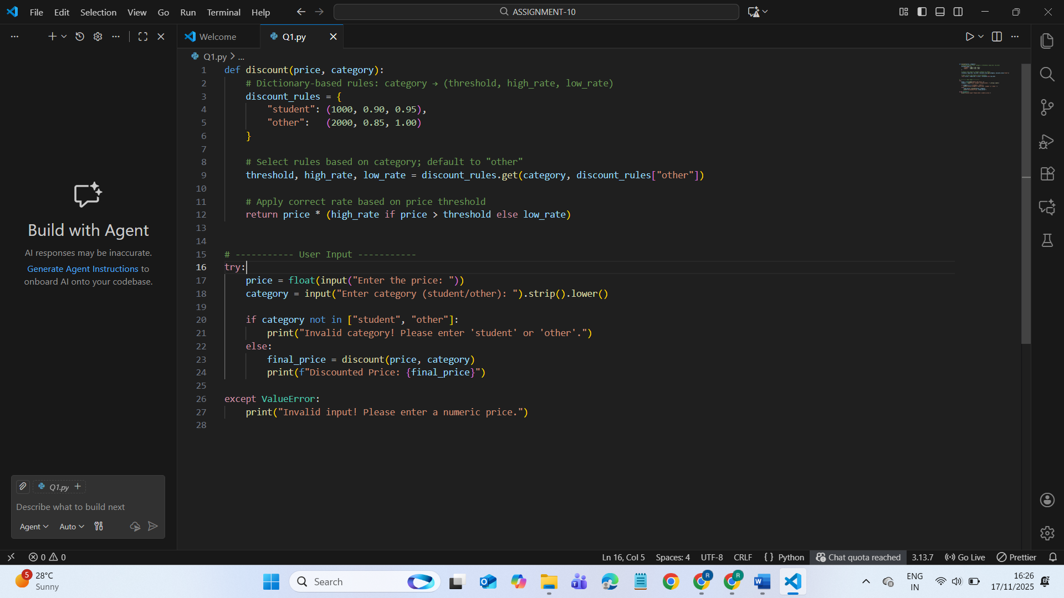  OUTPUT:  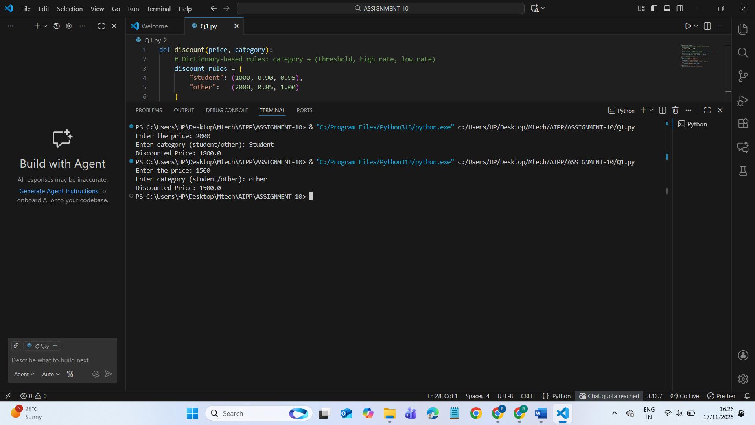  Task Description #2 – Optimize Redundant Loops  Task: Give AI this messy loop and ask it to refactor and optimize.  Python script  def find_common(a, b):  res = []  for i in a:  for j in b:  if i == j:  res.append(i)  return res  Expected Output:  Cleaner version using Python sets (set(a) & set(b))  PROMPT:  "Refactor the following Python code by removing redundant nested loops and optimizing it using Python set operations. Replace the brute-force comparison with a cleaner and faster solution using set(a) & set(b).”  CODE:  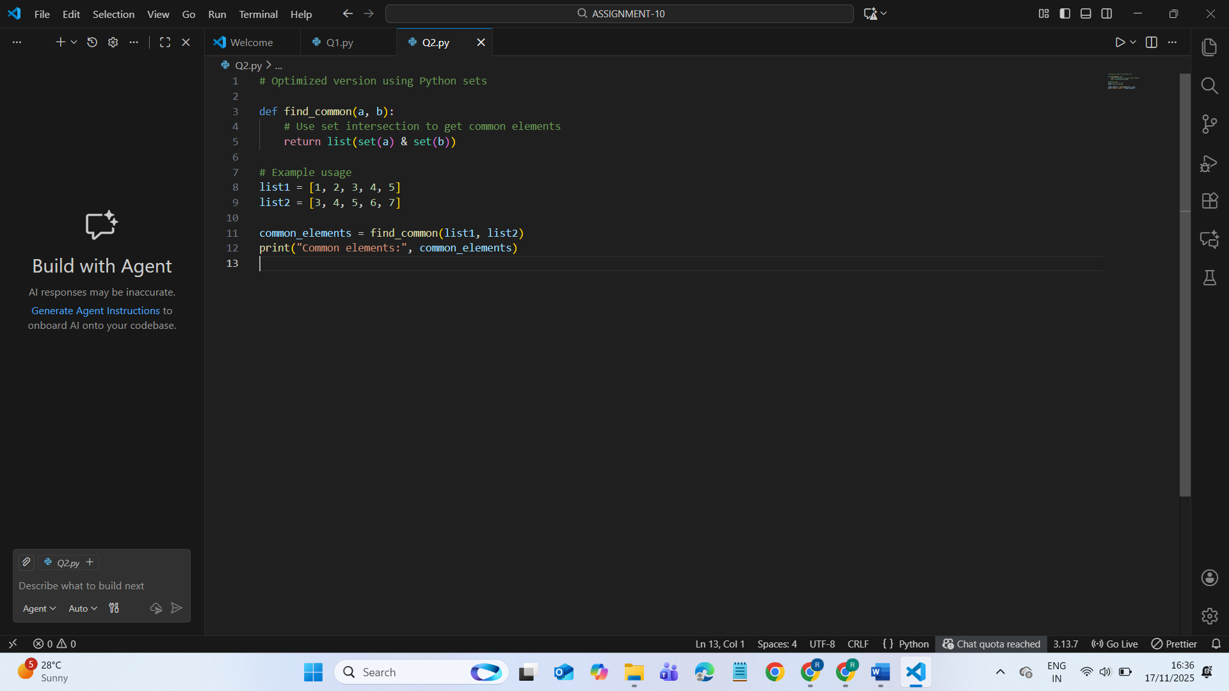  OUTPUT:  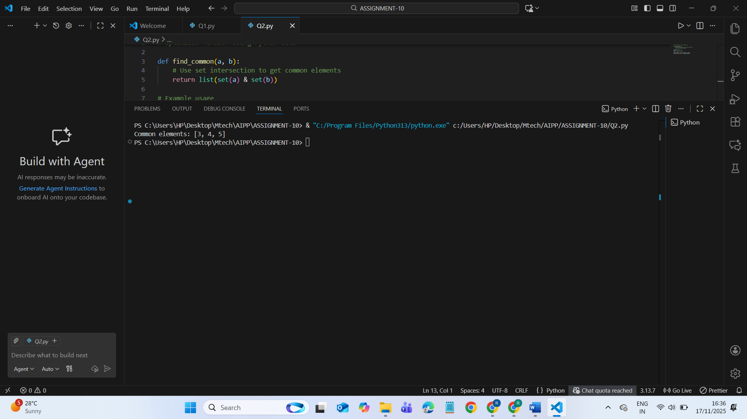  Task Description #3 – Improve Class Design  Task: Provide this class with poor readability and ask AI to improve:  - Naming conventions  - Encapsulation  - Readability & maintainability  Python Script  class emp:  def __init__(self,n,s):  self.n=n  self.s=s  def inc(self,p):  self.s=self.s+(self.s*p/100)  def pr(self):  print("emp:",self.n,"salary:",self.s)  Expected Output:  - Employee class with meaningful methods (increase_salary, display_info), formatted output, and added docstrings.  PROMPT:  Refactor the following poorly written Python class to improve naming conventions, encapsulation, readability, and maintainability.  Please rewrite it using proper class structure, clearer method names (e.g., increase_salary, display_info), meaningful attribute names, formatted output, and add appropriate docstrings.  Messy code to improve:  CODE:  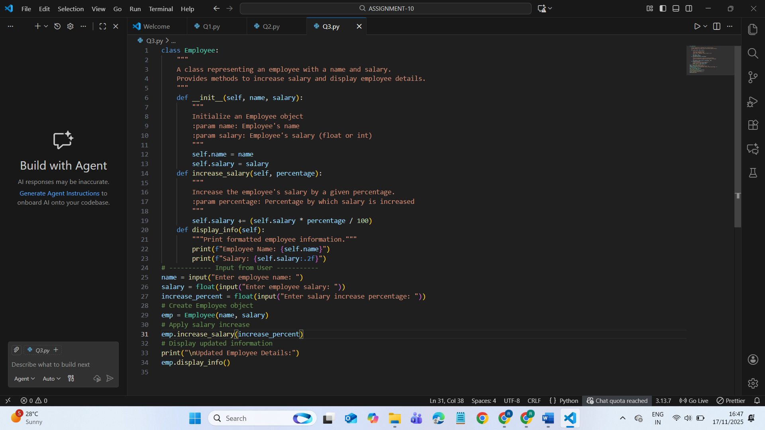  OUTPUT:  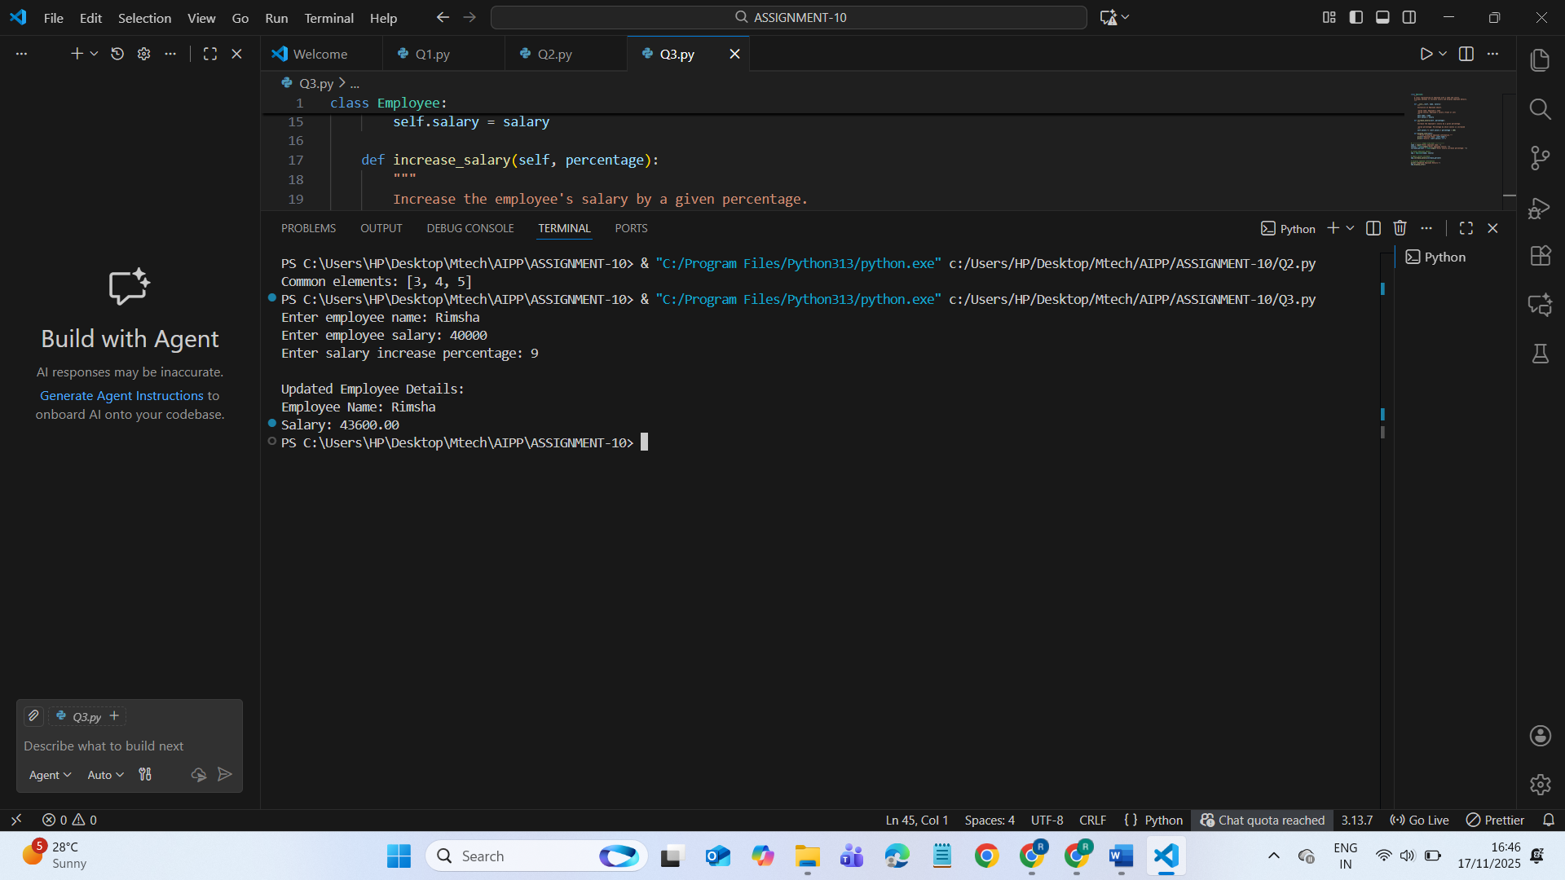  Task Description #4 – Modularize Long Function  Task: Give AI this long unstructured function and let it modularize into smaller helper functions.  Python Script  def process_scores(scores):  total = 0  for s in scores:  total += s  avg = total / len(scores)  highest = scores[0]  for s in scores:  if s > highest:  highest = s  lowest = scores[0]  for s in scores:  if s < lowest:  lowest = s  print("Average:", avg)  print("Highest:", highest)  print("Lowest:", lowest)  Expected Output:  - Split into functions: calculate_average, find_highest, find_lowest.  - Clean main process_scores() using helper functions.  PROMPT:  Refactor the following long, unstructured Python function by breaking it into smaller helper functions.  Create separate functions: calculate_average(), find_highest(), and find_lowest().  Improve readability, maintainability, and keep a clean process_scores() that calls these helpers.  CODE:  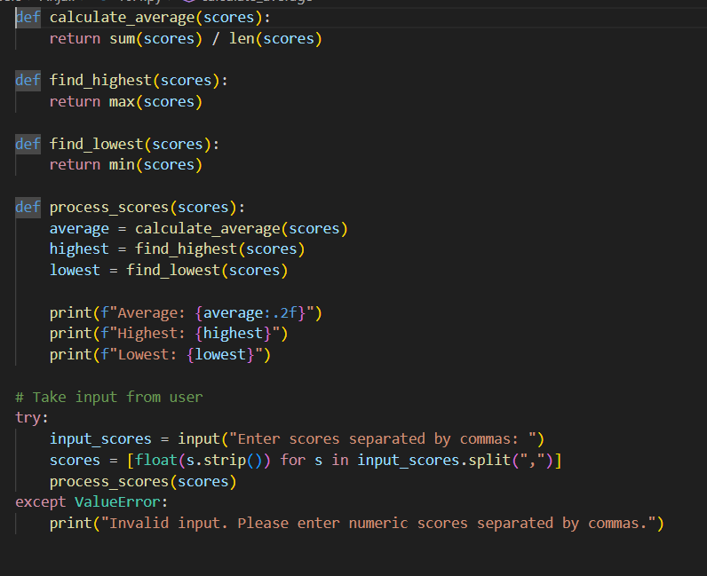  OUTPUT:  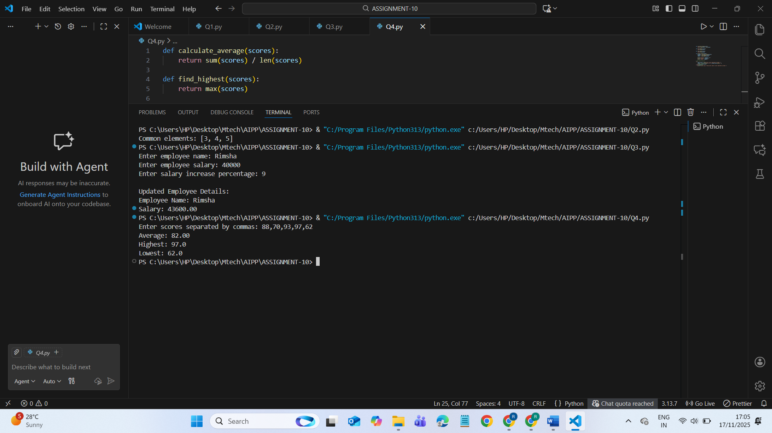  Task Description #5 – Code Review on Error Handling  Task: Provide AI with this faulty code and ask it to improve error handling, naming, and readability.  Python Script  def div(a,b):  return a/b  print(div(10,0))  Expected Output:  Function with proper error handling using try-except.  Better naming (divide_numbers).  AI-generated docstring explaining error handling.  CODE:  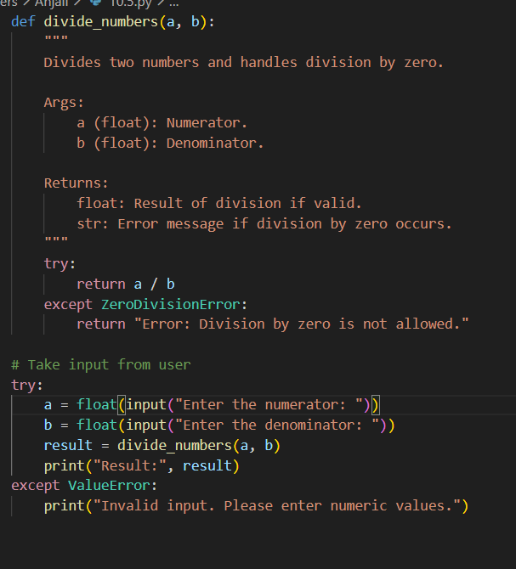  PROMPT:  Refactor the following Python function by improving error handling, renaming the function for clarity, and enhancing readability.  Add a try-except block to handle division errors (like division by zero) and include a helpful docstring explaining what the function does and how errors are managed.  OUTPUT:  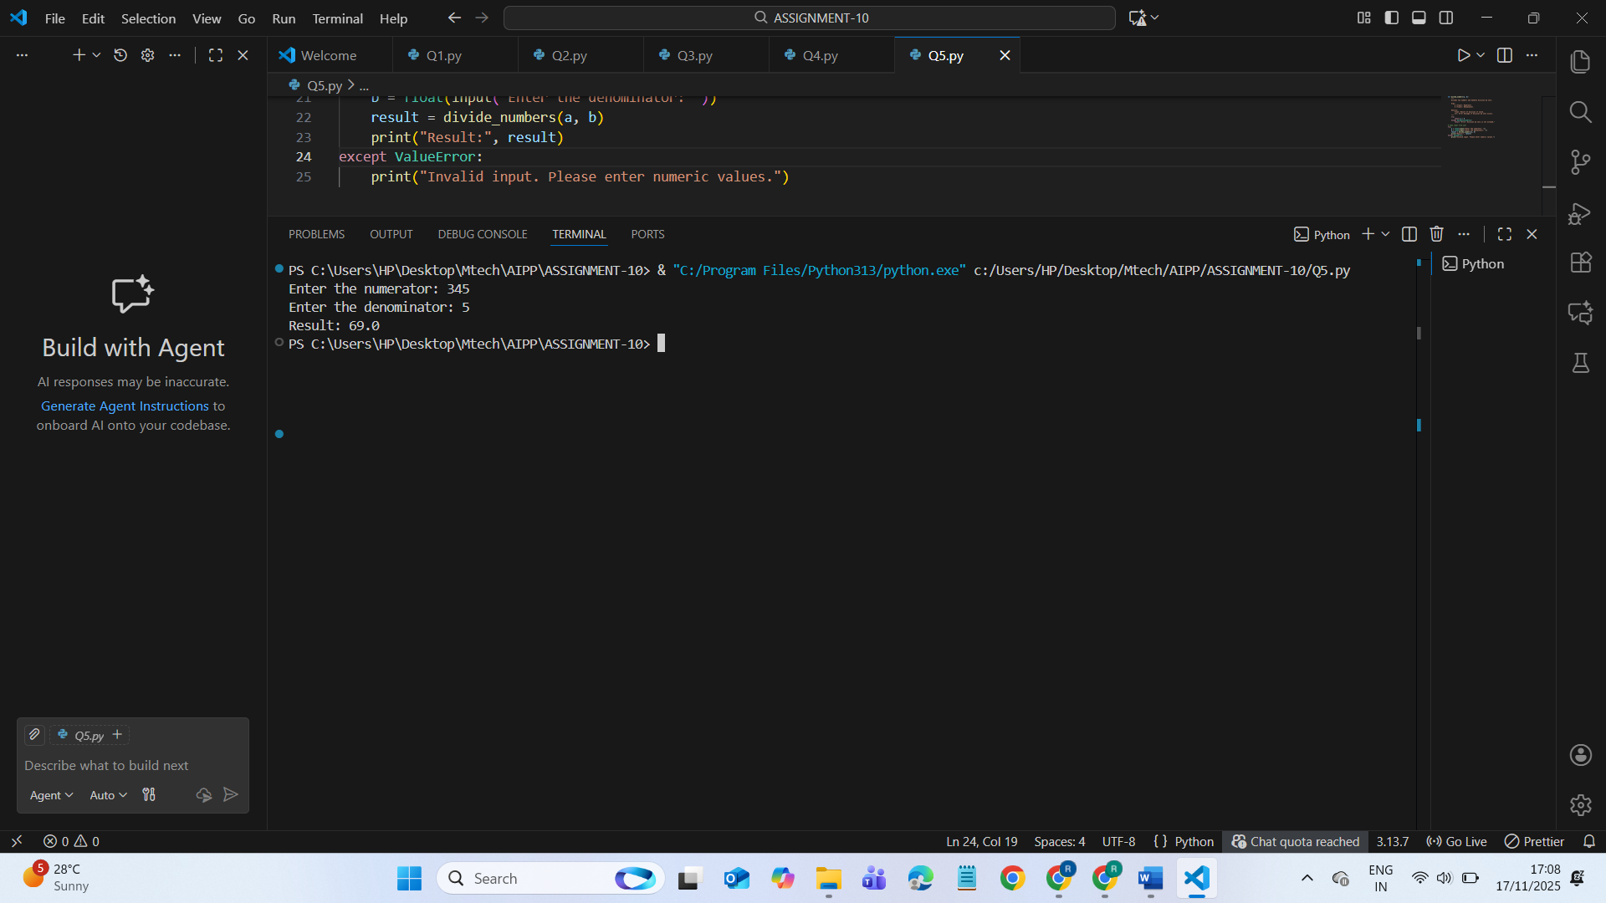  Task Description #6 – Complexity Reduction  Task: Use AI to simplify overly complex logic.  Sample Input Code:  def grade(score):  if score >= 90:  return "A"  else:  if score >= 80:  return "B"  else:  if score >= 70:  return "C"  else:  if score >= 60:  return "D"  else:  return "F"  Expected Output:  - Cleaner logic using elif or dictionary mapping.  PROMPT:  Refactor the following Python function by reducing unnecessary nested conditions and improving readability.  Rewrite the grading logic using either elif statements or a cleaner dictionary-based approach  CODE:  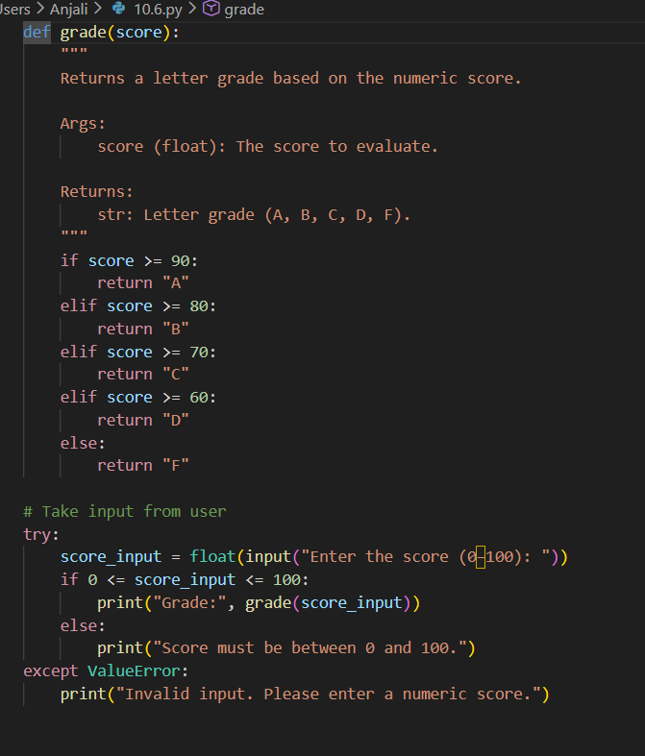  OUTPUT:  